### [**Bunny Sliceform**](https://papercraftetc.blogspot.com/2015/03/bunny-sliceform.html)

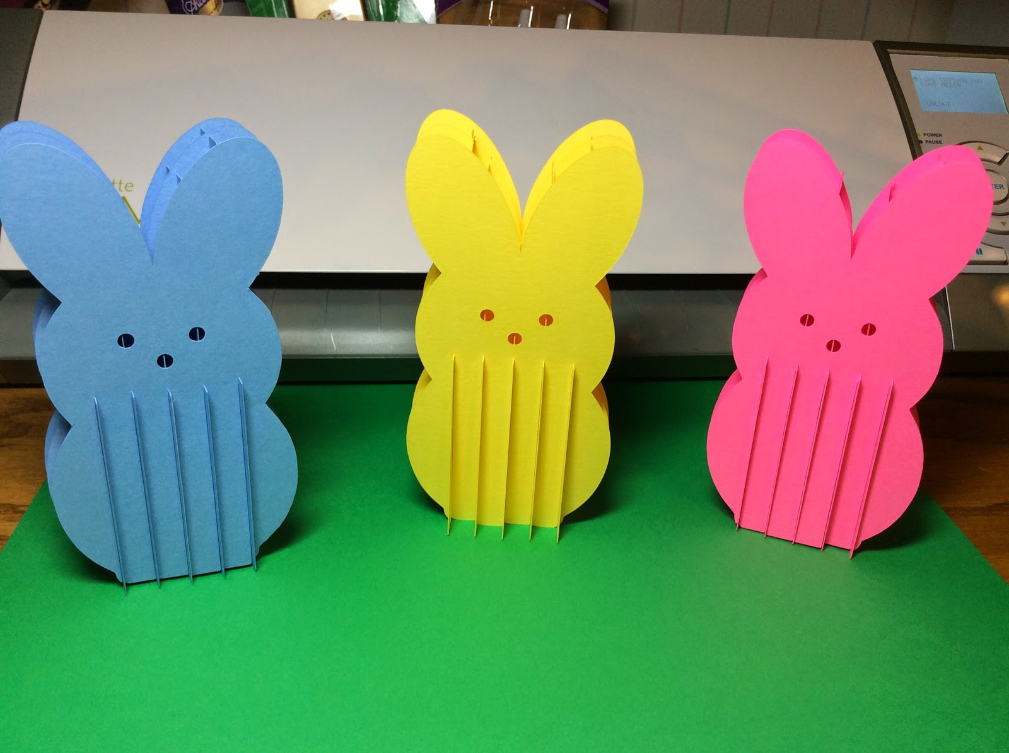

Bunnies are an Easter tradition. I love their pastel colors. The bunnies presence really brighten a room. Sliceforms are my obsession; so what better way to combine my passion for both of them.

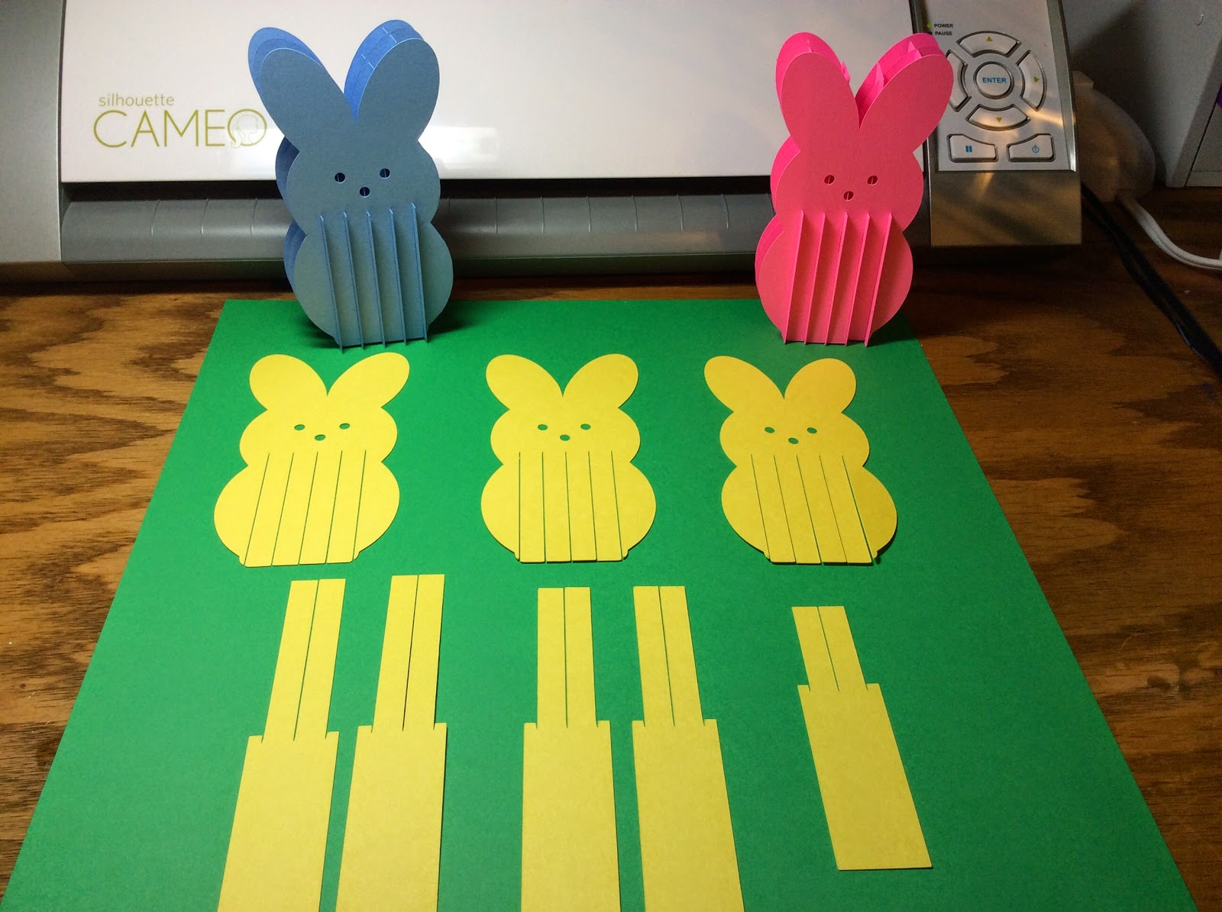

Separate the slices. The rectangular slices should be ordered from longest to the shortest.

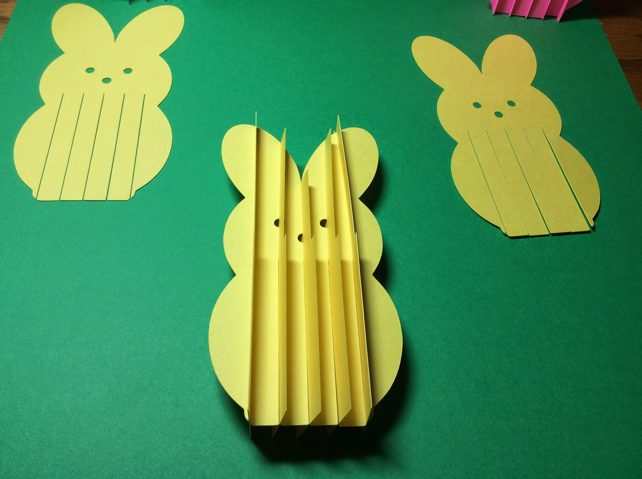

Starting at the left hand side, slide the longest rectangle into the first left slot. Then slide the next shortest size. The middle piece is the shortest rectangle. The next two slices increase in size. Above is a picture of what it should look like when all the rectangular slices are attached.

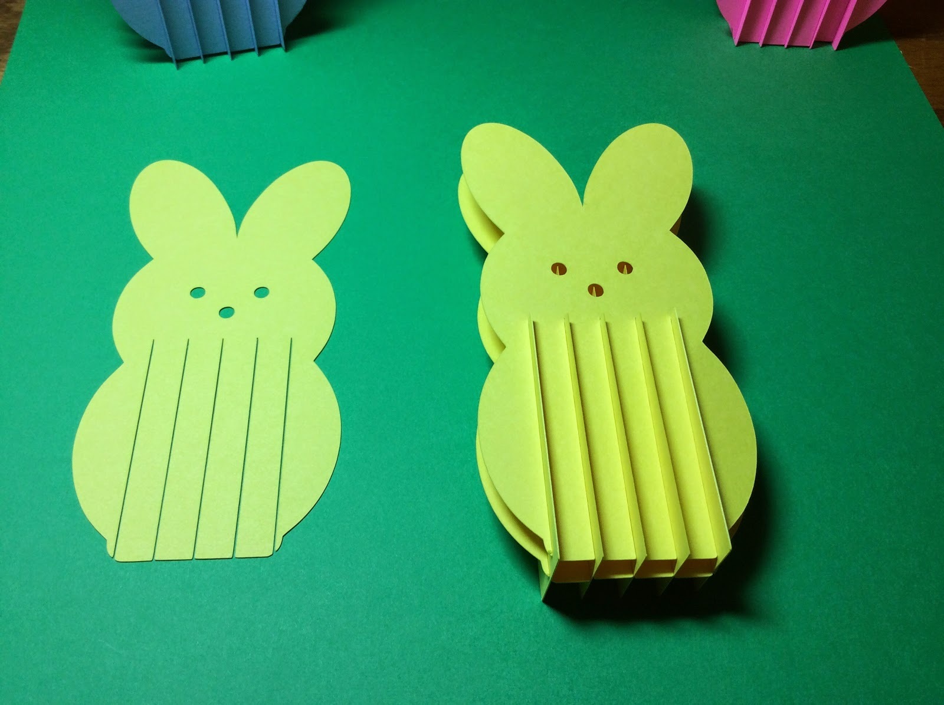

Slide the bunny piece onto one side as shown above.

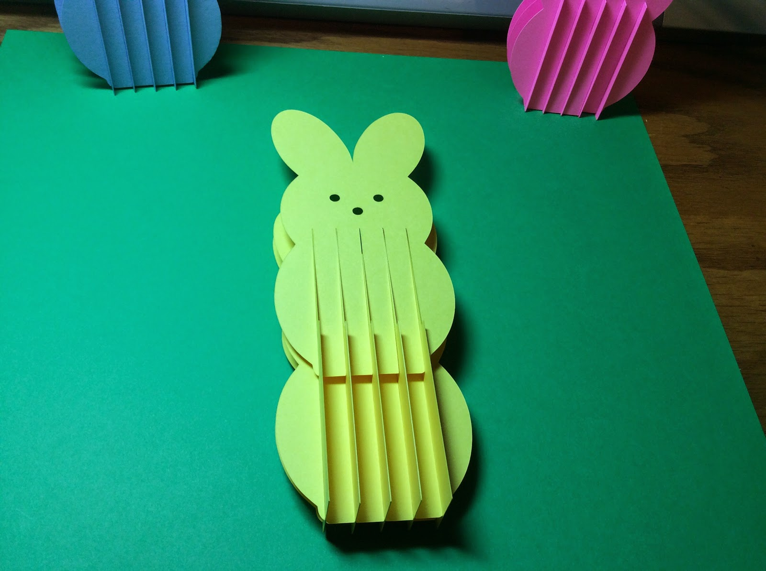

Turn the bunny over and repeat.

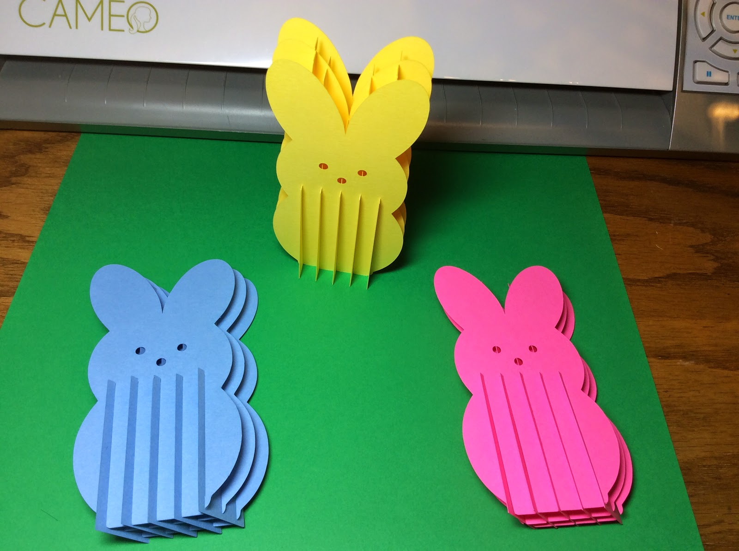

The bunnies are so cute. They can fold flat for mailing.

Happy Easter!